Name _____________________________________

Clock Partners

__________________________
12 o’clock partner
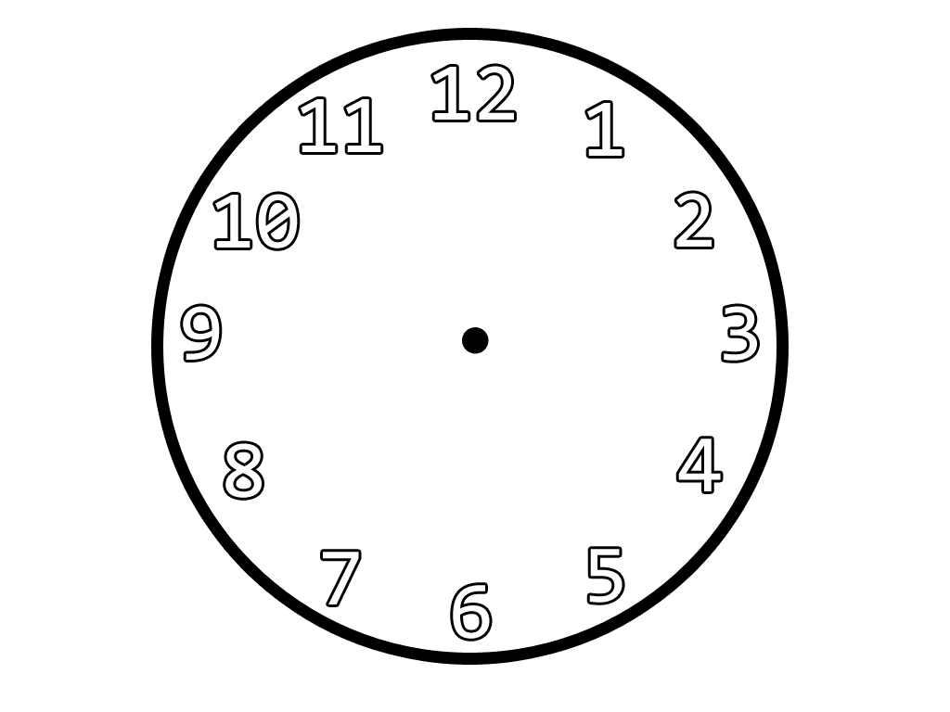

____________________ ______________________
9 o’clock partner 3 o’clock partner

__________________________
6 o’clock partner

